Troubleshooting Guide



**Troubleshoot OneDrive Issues**

Contents

1. OneDrive Synchronization Issues 3

2. OneDrive Editing Files Issue 5

3. One drive configuration issues 6

4. Restore OneDrive Feature 10

# OneDrive Synchronization Issues

This discusses the issues that user might encounter while configuring OneDrive in local machines and issues that may arise while the OneDrive is synced in user’s local machine

1. 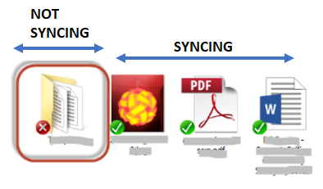Files are not syncing between local machine and online, the folders from local machine are appearing like the below:

This can be resolve by stopping the sync then re-syncing user’s OneDrive in their local machines. Please follow the steps below:

1. Right click the OneDrive icon in the lower right of your desktop:

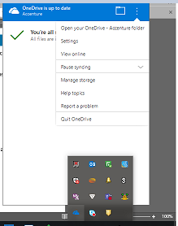

1. Click the Settings then the window below will open then click “Stop Sync” > OK.

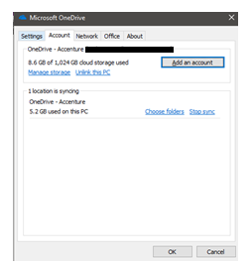

**NOTE**: “Stop sync” the OneDrive will leave the local copies in user’s local machine.

1. Re-sync OneDrive – access user’s OneDrive via <https://myoffice.accenture.com> then click “Sync”. Provide the necessary information.

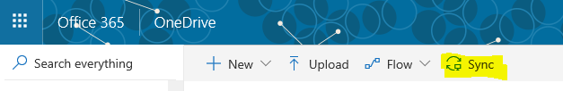

1. 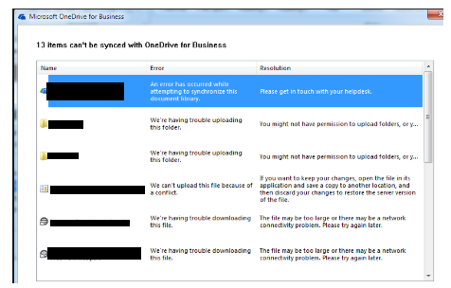There are files that were not syncing locally. User might get the below window as warning.

There are file types that are not allowed or blocked to be sync with local machine. Kindly refer to this [article](https://support.office.com/en-us/article/invalid-file-names-and-file-types-in-onedrive-onedrive-for-business-and-sharepoint-64883a5d-228e-48f5-b3d2-eb39e07630fa).

# OneDrive Editing Files Issue

At times, users might not be able to edit a file that was shared to them due to proper permissions were not applied on the specific files.

The file's owner should check permission, this should be done from the OneDrive web <https://myoffice.accenture.com>

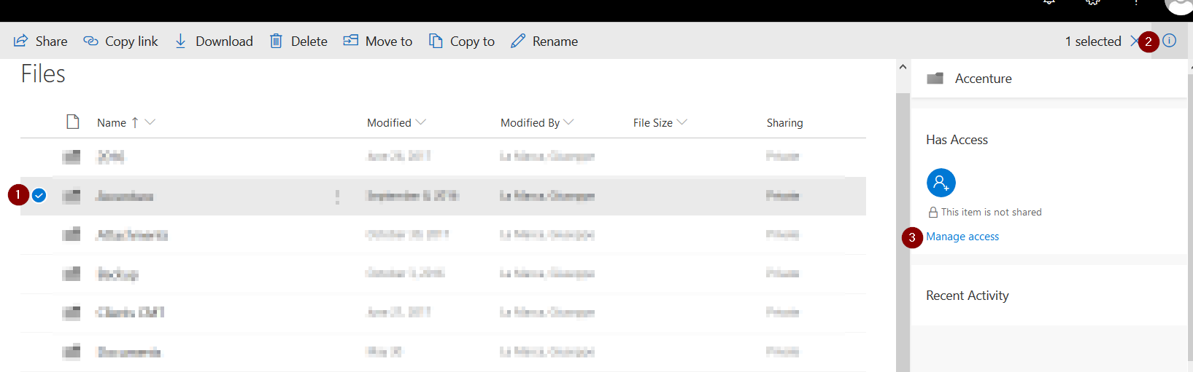

1. Browse to the file and select it.

2. Click on the information icon on the Top Right corner.

3. Click on Manage Access.

Users are going to be listed with Owner permissions (can edit) and Reader (only can read).  
If user is not Listed will not have access to the file, if is listed with Read permissions will not be able to Edit/Save changes.

[**Share files in OneDrive for Business**](https://support.office.com/en-us/article/share-onedrive-files-and-folders-9fcc2f7d-de0c-4cec-93b0-a82024800c07#OS_Type=OneDrive_-_Business) to know more about Files and Folders permissions.

# One drive configuration issues

This discusses the issue that users may encounter while configuring their OneDrive in local machine and while OneDrive is already configured:

Following are reasons why users are unable to configure OneDrive to their local machines:

1. User is using non- Accenture managed laptop
2. Only Accenture managed laptop/machines can configure OneDrive. Personal machine/laptop is not allowed.
3. User is blocked from in using OneDrive and getting the below errors.

When user is trying to configure OneDrive in local machine, user is getting the error below:

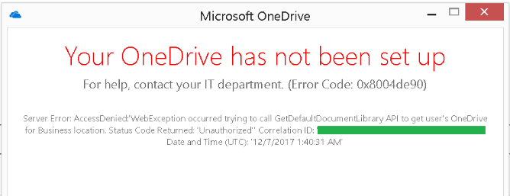

When accessing <https://myoffice.accenture.com>, user is getting HTTP403 error

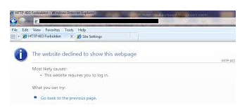

Users can also refer to [Configuring Sync](https://in.accenture.com/onedriveforbusiness/onedrive-pc-synchronization/configuring-sync/).

To query the status of user’s OneDrive access using his/her EID; to determine if he/she is blocked due to inclusion on a distribution list that is blocked for OneDrive access or was just on a blocked status. This tool is intended for service desk use for them to determine the cause of user’s OneDrive access being blocked and to apply quick resolution as necessary.

**How to use the tool:**

1. Go to [OneDrive Access Management Tool](https://mcportal.accenture.com/WebTools/OneDriveAccessManagement/UserStatus/UnblockingAutomation).

2. Typed-in the user’s EID on the given field then click the search button:

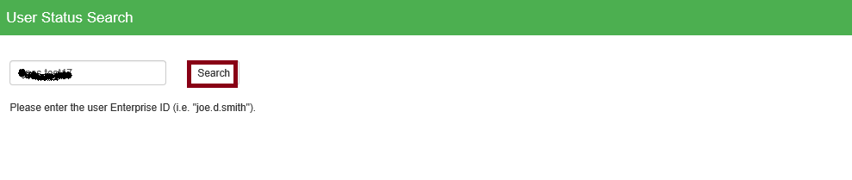

3. Wait for the completion process; a result will appear beside the search box. If a user is blocked due to he/she is included in one of blocked distribution list for OneDrive access, below result will appear:

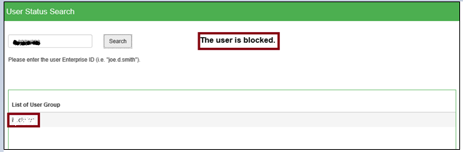

Note the name of the distribution list under “List of User Group” table and search its owners using the [Web Admin Tool](https://directory.accenture.com/webadmin) then click the “Group Management” link to redirect to the search for groups field:

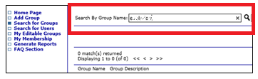

Typed-in the distribution list under the “Search by Group Name” field then click the search button. On the searched results, click the exact name of the distribution list that was used in the search field:

Inform the user about the owners of the distribution list to which, he/she should reach out to remove his/her inclusion on that group:

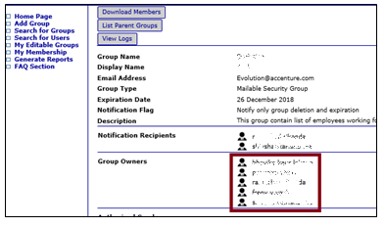

The should also be informed that once his/her name was removed on a distribution list, changes would take effect up to 24 hours.

4. If the user’s OneDrive is just on a blocked status without any inclusion on any distribution list that was blocked for OneDrive access, below result will appear:

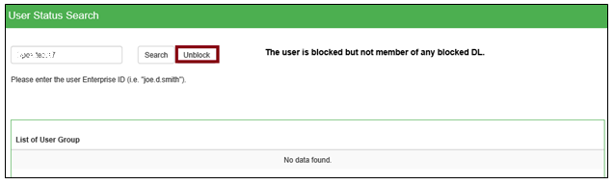

If this is the case, the user can be unblocked by clicking the “Unblock” button. After the unblocking process has been completed, the user should wait for 5 to 10 minutes before trying to access again his/her OneDrive.

5. If the user is not blocked, the below result will appear:

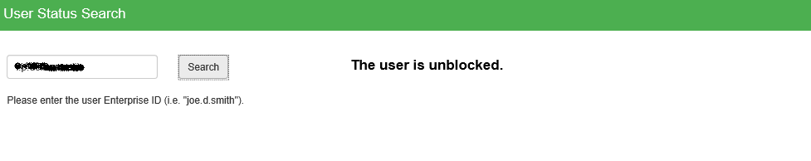

In this case if the user mentioned that he cannot access his/her OneDrive, kindly ensure that he/she is accessing the correct [URL for OneDrive](https://myoffice.accenture.com/) and the network connection he/she is using is not blocking the said URL.

If an error or permission issue was encountered on this tool and/or the tool did not resolve the user’s issue, kindly escalate the incident ticket to Messaging and Collaboration Service-Now queue which is **MSGCOLLAB-O365-OPER**.

**Related Links:**

[OneDrive Access Management Tool](https://mcportal.accenture.com/WebTools/OneDriveAccessManagement/UserStatus/UnblockingAutomation)

[Web Admin Tool](https://directory.accenture.com/webadmin)

[URL for OneDrive](https://myoffice.accenture.com/)

# Restore OneDrive Feature

Files Restore is a complete self-service recovery solution that allows administrators and end users to restore files from any point in time during the last 30 days. If a user suspects their files have been compromised, they can investigate file changes and allow content owners to go back in time to any second in the last 30 days. Now your users and your administrators can rewind changes using activity data to find the exact moment to revert to.

1. To use Files Restore, all a user needs to do is choose Settings and then Restore OneDrive
2. Users are presented with a histogram showing file activity over the last 30 days with an intuitive slider to “rewind” those changes.
3. They can then easily select the file or files to restore from that point in time.
4. The user then is prompted with a date range as well as the number of files to restore.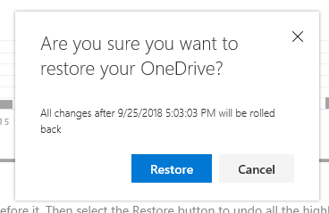
5. The user chooses to restore, and the files are then restored back into the users OneDrive.

Reference Blog is [here](https://techcommunity.microsoft.com/t5/OneDrive-Blog/Announcing-New-OneDrive-for-Business-feature-Files-Restore/ba-p/147436).

Limitations and Troubleshooting:

1. Files Restore uses version history and the recycle bin to restore OneDrive, so it's subject to the same restrictions as those features. When version history is turned off, Files Restore won’t be able to restore files to a previous version. For information about versioning settings, see Enable and configure versioning for a list or library at [link](https://faq.oit.gatech.edu/content/how-do-i-turn-version-history-feature-onedrive-business)
2. Deleted files can’t be restored after they’ve been removed from the site collection recycle bin—either by manual delete or by emptying the recycle bin.
3. If you upload a file or folder again after deleting it, Files Restore will skip the restore operation for that file or folder.
4. If some files or folders cannot be restored, a log file will be generated at the root folder of your OneDrive to capture the errors. The name of the file begins with “RestoreLog” followed by an ID (for example, RestoreLog-e8b977ee-e059-454d-8117-569b380eed67.log). You can share the log file with our support team to troubleshoot any issues that may occur.

Reference is [here](https://support.office.com/en-us/article/restore-your-onedrive-fa231298-759d-41cf-bcd0-25ac53eb8a15.).

***Disclaimer: ALL latest files/modifications will be gone or overwritten in user's OneDrive when they restored it to a certain date so tell the user to back up the new files that were uploaded or any modifications.***